Tutorial – 4

**Aim:** Write a shell script to generate mark sheet of a student. Take 3 subjects, calculate and display total marks, percentage and Class obtained by the student.

**Code:**

#!/bin/bash

read -p "Enter Marks for subject 1: " sub1

read -p "Enter Marks for subject 2: " sub2

read -p "Enter Marks for subject 3: " sub3

totalMarks=$((sub1 + sub2 + sub3))

percentage=$(echo "scale=2; ($totalMarks / 300) * 100" | bc)

# Determine the class obtained based on percentage

if (( $(echo "$percentage >= 80" | bc -l) )); then

class="Distinction"

elif (( $(echo "$percentage >= 60" | bc -l) )); then

class="First Class"

elif (( $(echo "$percentage >= 40" | bc -l) )); then

class="Pass Class"

else

class="Fail"

fi

echo "Total Marks: $totalMarks"

echo "Percentage: $percentage%"

echo "Class Obtained: $class"

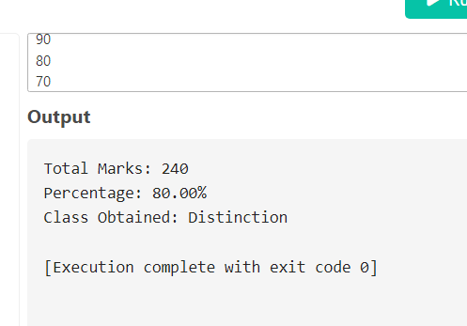**Output:**